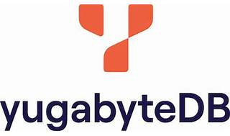

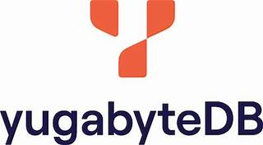

Explore

**YugabyteDB** is a high-performance, **cloud-native**, **distributed SQL database** that supports all PostgreSQL features. [It combines the flexibility of SQL, low-latency performance, continuous availability, and global scalability1](https://www.yugabyte.com/)[2](https://docs.yugabyte.com/preview/faq/general/)[3](https://www.yugabyte.com/yugabytedb/).

Here are **five free resources** where you can learn more about YugabyteDB:

1. [**Learn YugabyteDB**](https://learn.yugabyte.com/): Provides guided tutorials and hands-on coding experiences covering topics like YSQL Basics, Distributed SQL Concepts, and ORM Examples[4](https://learn.yugabyte.com/).
2. [**Yugabyte University**](https://university.yugabyte.com/courses/yugabytedb-fundamentals): Offers virtual training on key YugabyteDB features, including sharding, replication, load balancing, and geo-distribution[5](https://university.yugabyte.com/courses/yugabytedb-fundamentals).
3. [**Distributed SQL and YugabyteDB Fundamentals on Udemy**](https://www.udemy.com/course/distributed-sql-and-yugabytedb-fundamentals/): Deep dive into distributed SQL concepts and YugabyteDB architecture through exercises and practical examples[6](https://www.udemy.com/course/distributed-sql-and-yugabytedb-fundamentals/).
4. [**YugabyteDB Documentation**](https://docs.yugabyte.com/preview/faq/general/): Comprehensive documentation covering various aspects of YugabyteDB, from installation to advanced schemas and table management[2](https://docs.yugabyte.com/preview/faq/general/).
5. [**Baeldung’s Quick Guide to YugabyteDB**](https://www.baeldung.com/yugabytedb): Learn about the distributed SQL nature of YugabyteDB and explore its architecture[7](https://www.baeldung.com/yugabytedb).

Happy learning! 🚀📚